

**Mobile CRM**

**V1.0**



SOLUTION APPROACH DOCUMENT

For

**Mobile Document**

**v1.0**

By

Acidaes Solutions Pvt. Ltd.

Infospace, Tower 1, Ground Floor, Block B, Plot No. 2,

Sector 62, NOIDA - 201 309, UP, India;

Tel: (+91) 120 6784333; Fax: (+91) 120 6784334

Confidential and Proprietary

©Copyright 2011-2016, Acidaes Solutions Pvt. Ltd.

All Rights Reserved.

*The management team of Acidaes (the Company) has prepared this business document, and is being furnished to selected individuals within The Bank for the sole purpose of proposal evaluation, for sale of CRMNEXT and CRMNEXT services. This business document is confidential, and contains ideas, concepts, processes and other information that the Company considers proprietary. Readers are to treat the information contained herein as confidential and may not disseminate, copy or reproduce it in any form without the expressed written permission of the Company. ‘Acidaes’, ‘CRMNEXT, ‘Simplifying Technology’ and ‘smart.easy.complete’ is applied trademarks of Acidaes Solutions Pvt. Ltd. All other trademarks are the property of their respective owners.*

Revision History

|  |  |  |  |  |  |
| --- | --- | --- | --- | --- | --- |
| Sr. No. | Date | Version | Description | Author | Reviewer |
| 1 | 25-05-2018 | 1.0 | Document Created | Manish | Imtiyaz A |

Table of Contents

1. Introduction 5

2. Objective 5

3. Scope 6

4. Landing Page 9

4.1 Landing Page Summary 9

5. Lead Management 12

5.1 Lead Home page 12

5.2 Lead listing 12

5.3 Lead 360 view 13

5.4 Lead detail 14

5.5 Lead Creation 14

6. Contact 15

7. Customer view 18

8. Tasks 22

9. Calendar 27

10. Alerts 32

# Introduction

This is an approach document for implementing CRMNEXT Mobile Application relevant to Customer, Sales Management for I&M Bank. This document is prepared basis the business requirement from Bank given initially and the subsequent feedback after demo.

# Objective

The objective of this document is to elaborate on the requirement of a bank to build a system to increase sales effectiveness and efficiency in the organization through CRM implementation for Mobile.

Record creation will become more simplified, easier and quicker for a User using mobile application. A mobile layout would have minimum number of fields for a successful record creation there by saving quality time.

The amount of information visible on the mobile app is restricted to the basic information. To view detailed information, user will have to log in to the desktop application.

# Scope

Mobile Application will be available for sales users only as it would give the RMs and Product Partners a quick view of their customers and prospects. The users will also be able to see the related tasks and appointments of the customer. The Lead creation/capturing with minimum fields will also be facilitated through Mobile.

This document covers the Mobile Application of CRMNEXT catering to Lead Capturing, Contact Management, Activity Management, Alerts, Customer/Account view. For detailed functionality, please refer the leads and Sales management document and Customer 360 information sent separately.

On installing the app, the user can login in the following ways:

1. Manually entering the URL

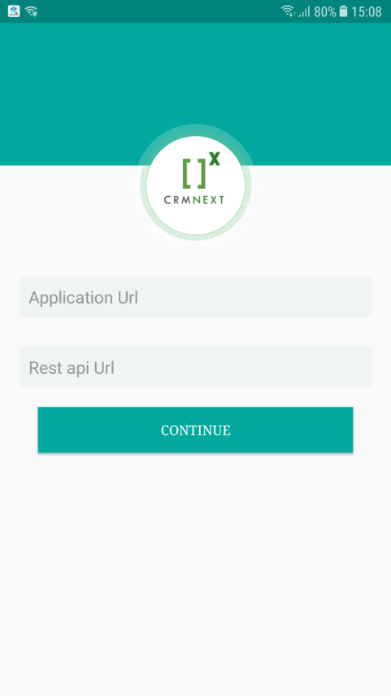

Figure 1: Mobile URL

1. QR Code scan: QR Code can be generated by performing the following steps- Personal Settings 🡪 My Details 🡪 Generate QR Code

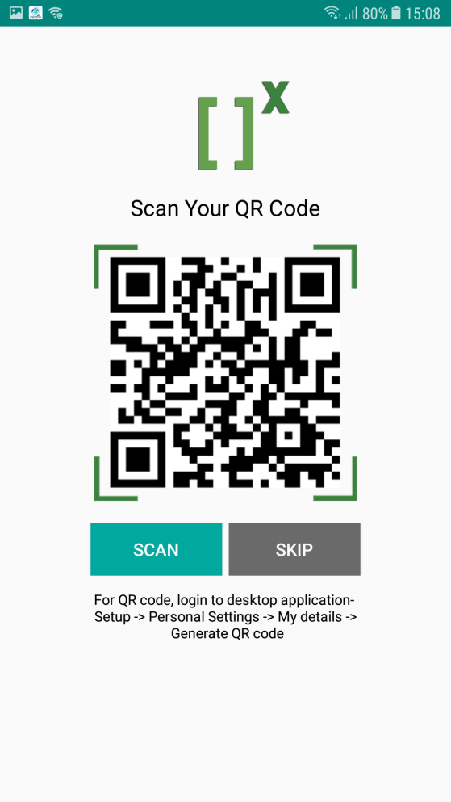

Figure 2: QR Code

The user can now log-in through his/her login credentials.

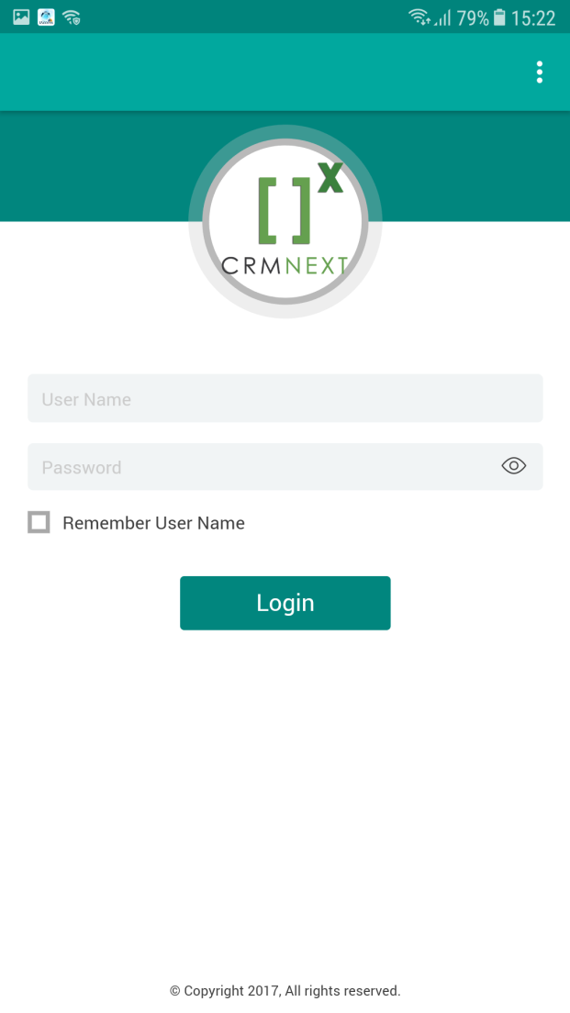

Figure 3: User Login Page

# Landing Page

## Landing Page Summary

The objects which the role is seeing will be as per their access right given.

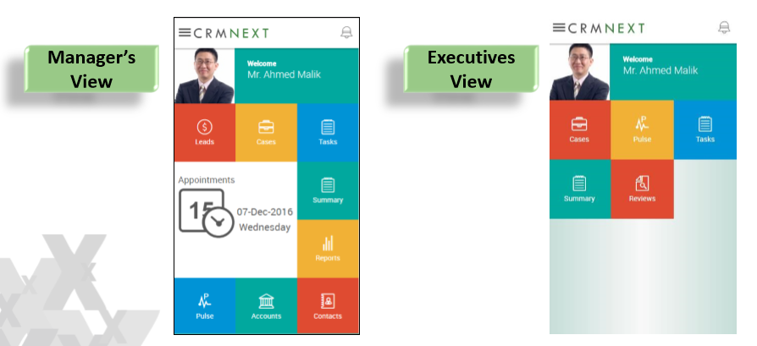

Figure 4 - Illustrative Screen of Landing Page

The mobile landing page comprises of the following tiles:

* Customer
* Contact
* Appointment
* Task
* Calendar
* Deals
* Alerts

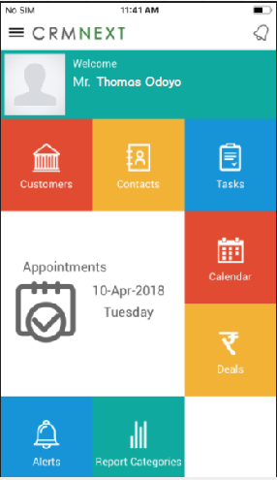

Figure 5-Illustrative Mobile Landing Screen

Each of these tiles direct to the views of the respective objects. User can also choose to select the object from the left panel, as shown below:

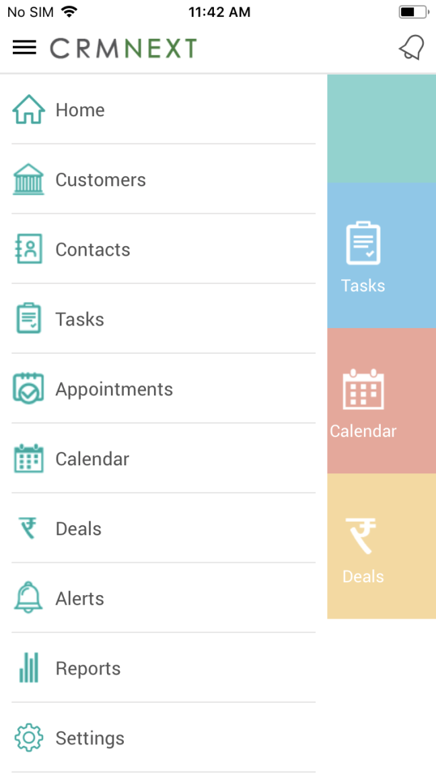

Figure 6: Mobile Landing page panel

# Lead Management

## Lead Home page

Once the mobile user clicks on the Leads object on the landing page, he will be directing to the Lead home page, illustration of same is as below –

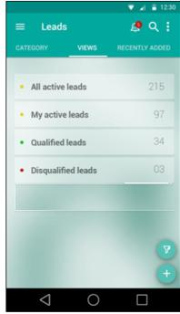

Figure 7-Lead Home Page

## Lead listing

On clicking of any of the view listed below:

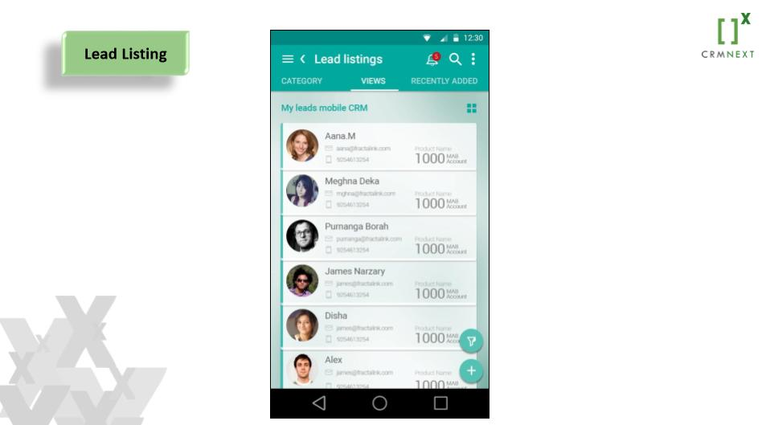

Figure 8-Lead Listing Page

## Lead 360 view

On clicking on any of the lead

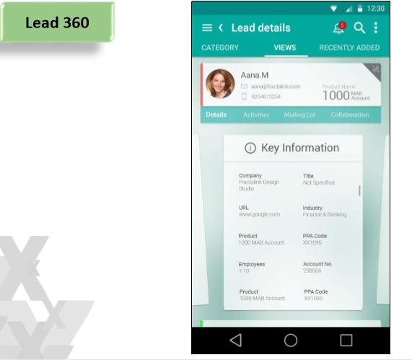

Figure 9-Lead 360 Page

## Lead detail

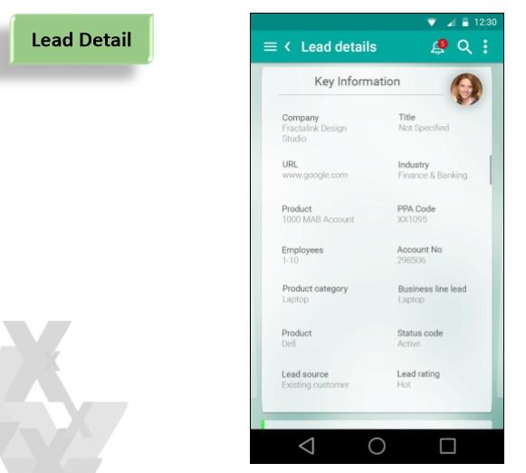

Figure 10-Lead Detail

## Lead Creation

On clicking on the + symbol available at lead page, user will be able to create the lead by entering the basic details

|  |  |
| --- | --- |
| Field Name | Description |
| Name | User will be entering the name of lead |
| Product category | Category of Product |
| Product | Product Name |
| Mobile | Contact details |
| Email Address | Email id of lead |
| Segment | The segment of |

Table 1-Lead Fields

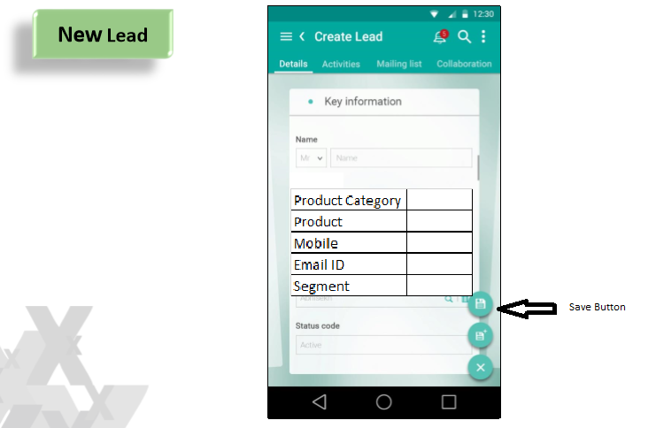

Figure 11-New Lead Creation

# Contact

From landing page on selecting the tile and navigating to contact object, the following view category/views will be available:

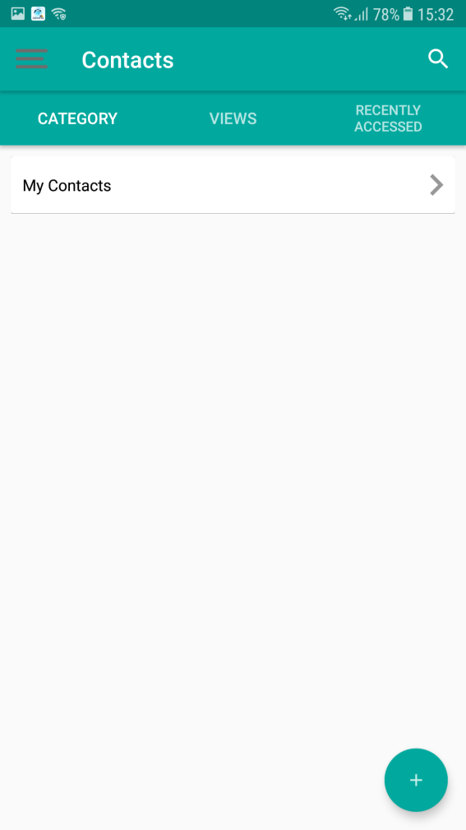

Figure 21: Contact Category

The views for contact have been segregated as:

* Business Contact
* Ownership Contact
* Authorized Signatory

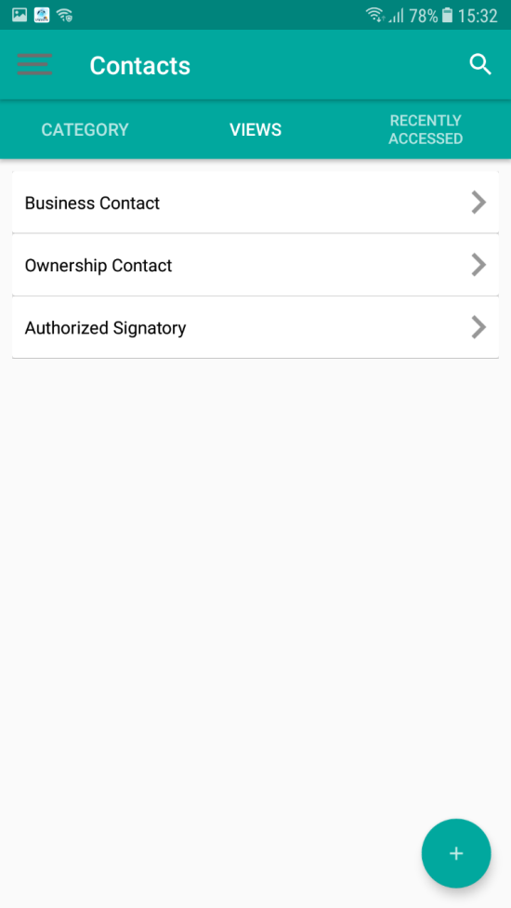

Figure 22: Contact Views

Business Contact displays all the contacts associated with the Customers of the logged in user.

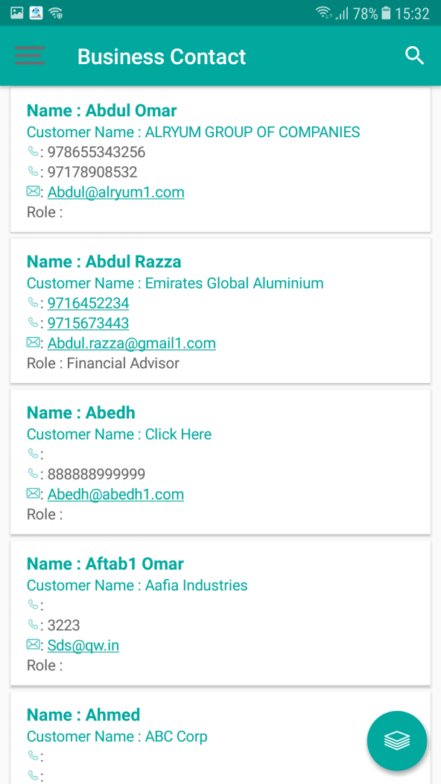

Figure 23: Business Contact

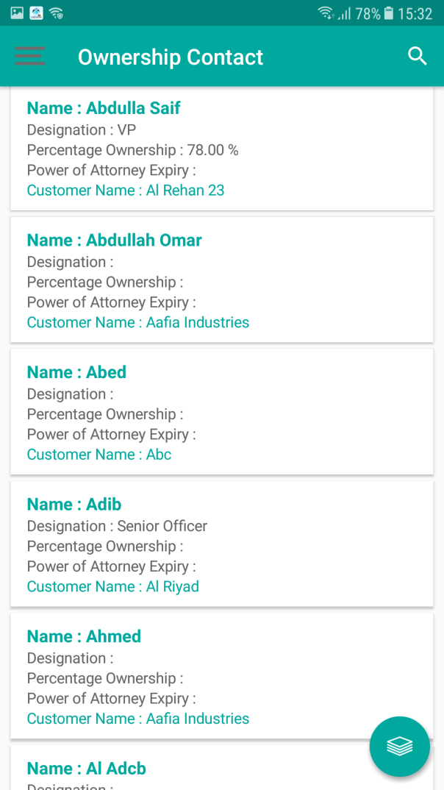

Figure 24: Ownership Contact View

# Customer view

On this page it will go the further search of Customer from two views as:

1. My Customers
2. My Prospect

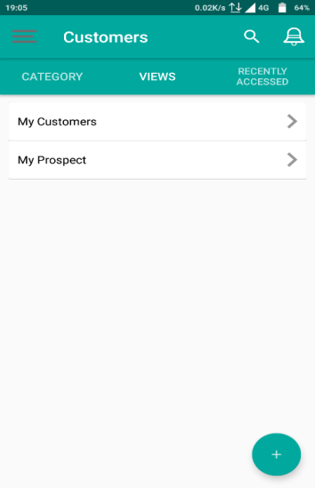

Figure 25-Customer Views

List of Customers from the View ‘My Customers’

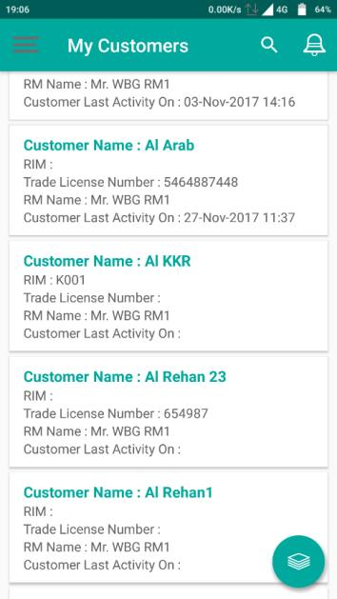

Figure 26-Customer Views

Searching the Customer:

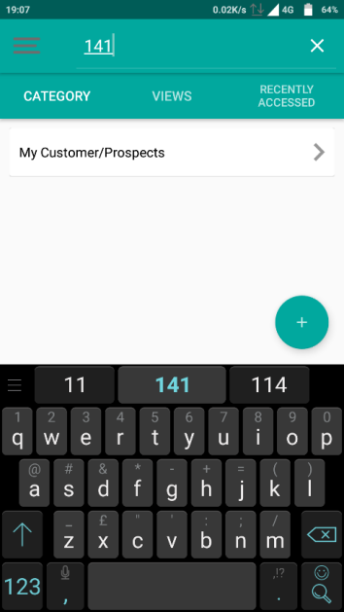

Figure 27-Customer Search

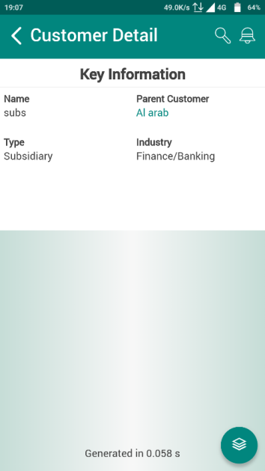

Figure 28-Customer Search Page

The detail page of the Customer will look like:

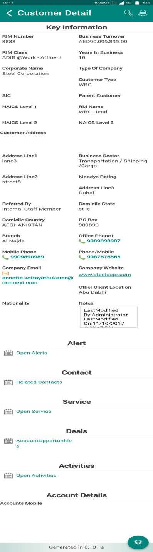

Figure 29-Customer Detail

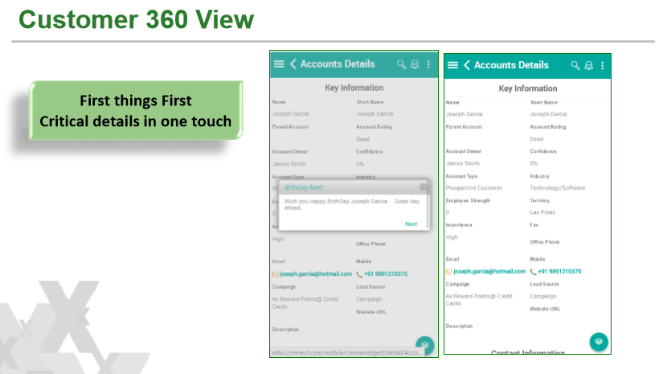

Figure 30-Customer 360

# Tasks

Users can create Tasks through the mobile application. The user can create/view tasks through the Task Tile on the homepage.

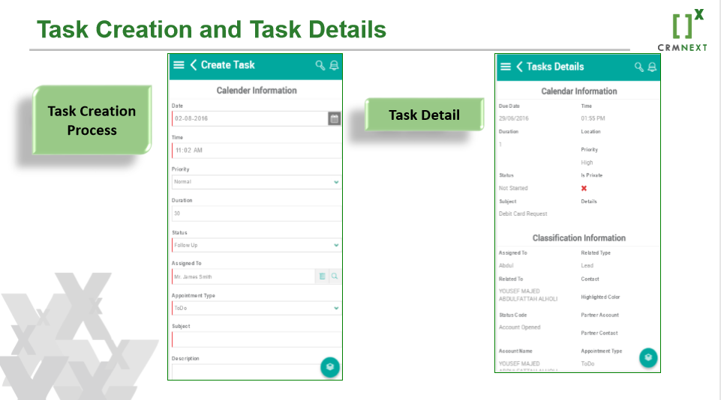

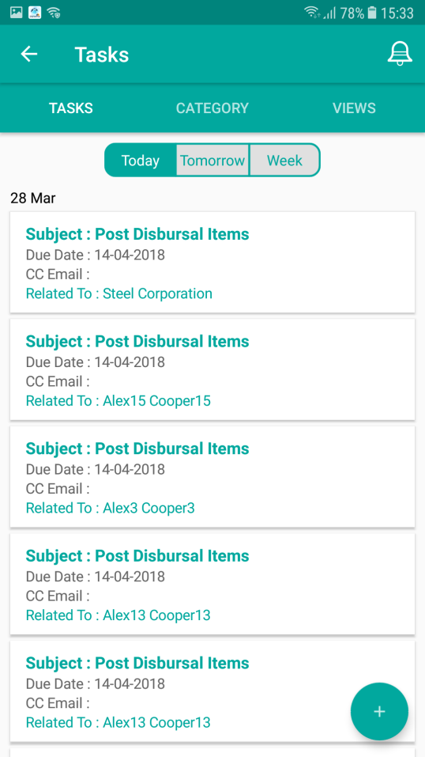

Figure 31: Task - Date/ Week

All the Tasks can be viewed in the Task Views – My Confirmable Task, My Non-Confirmable Task.

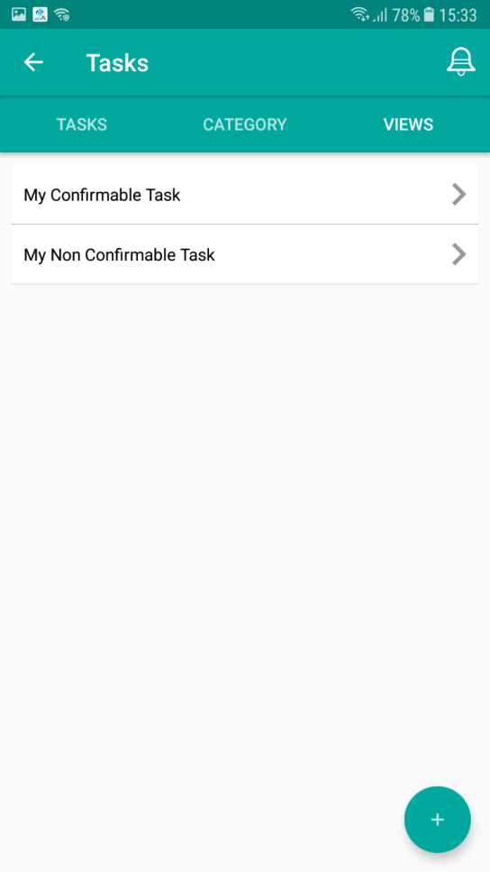

Figure 32: Task Views

These views comprise of only the Tasks that have been assigned to the user. For the Tasks that have been assigned to the user’s subordinates, the user will have to check in the desktop application.

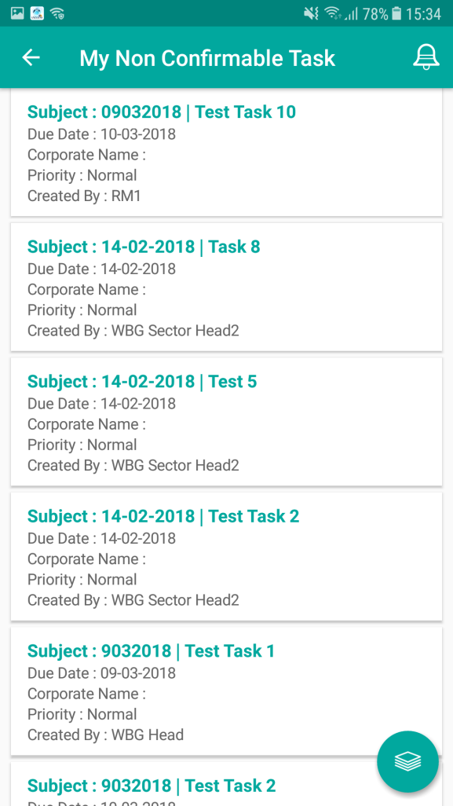

Figure 33: My Non-Confirmable Task

Clicking on the record will display the detail page of the record, as below.

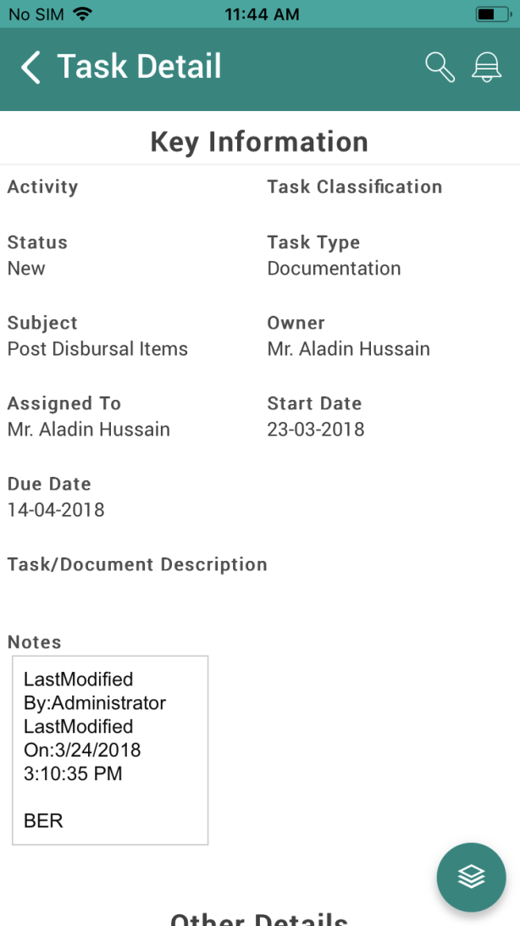

Figure 34: Task Detail Page

User can also edit the Task by clicking on the stack icon. The New/Edit is shown below.

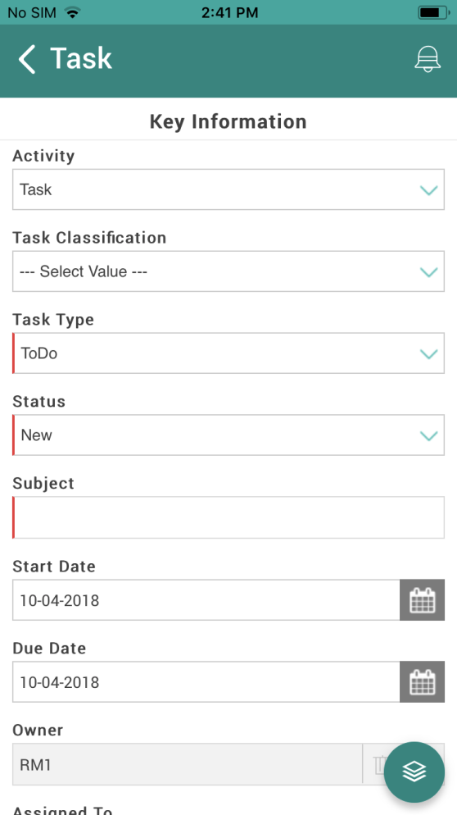

Figure 35: Task New/Edit Page

For detailed functionality please refer to LEAP CRM Customer Management section 9. Activity Management.

# Calendar

The Calendar displays the all the related activities of the user at a go. The calendar can be accessed from the homepage through the Calendar Tile.

On clicking the tile, the calendar will open as below:

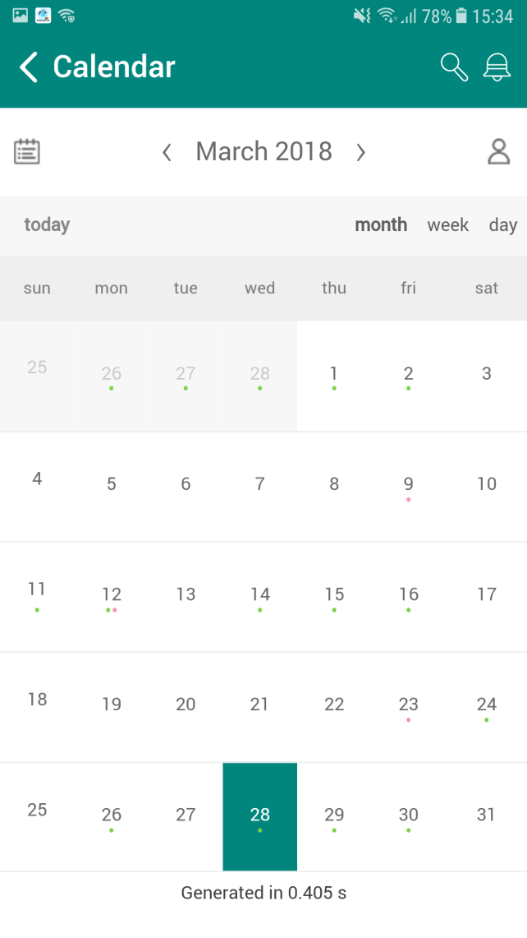

Figure 36: Calendar (Monthly)

Appointments are indicated with green dots. Tasks are indicated with pink dots.

The above calendar is a monthly representation. User can choose to view the calendar as day-wise or weekly, as below.

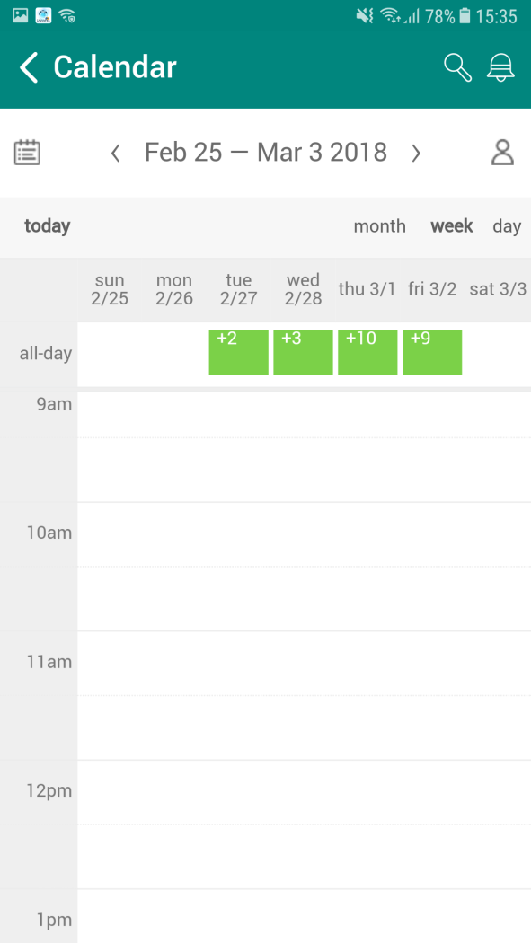

Figure 37: Calendar (Weekly)

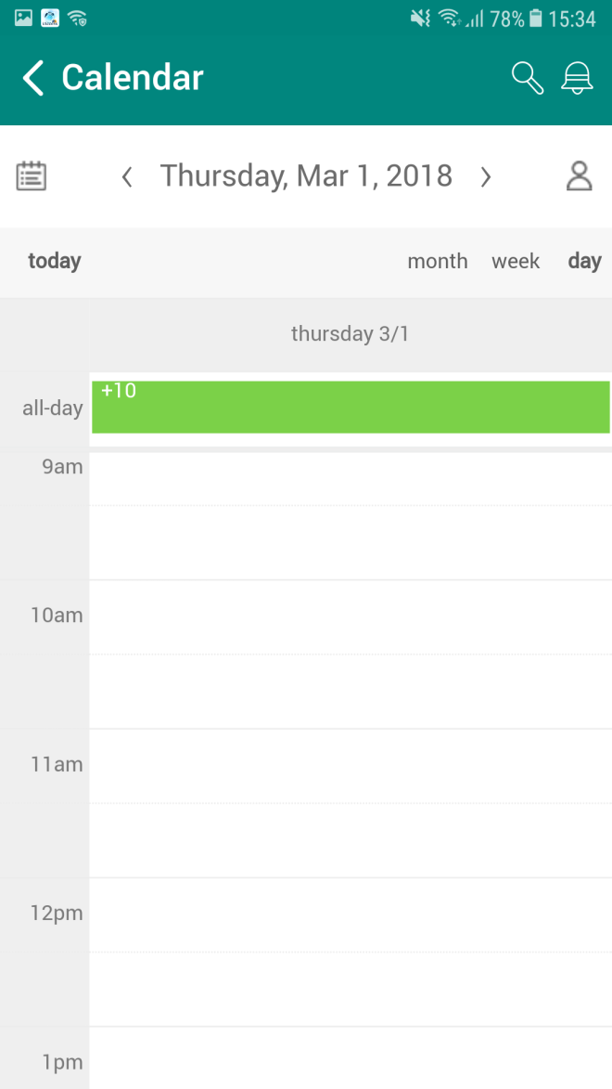

Figure 38: Calendar (Day-wise)

On clicking the entries, user will be prompted with the time and subject of the activity, as below:

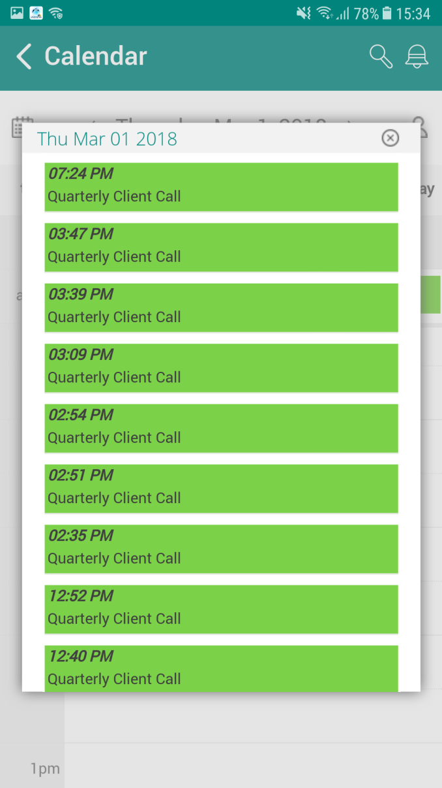

Figure 39: Calendar Appointment (with time and subject)

Clicking on the record will navigate to the activity detail page (Refer image: Figure 16)

Green colour indicates Appointments and Pink colour indicates Task.

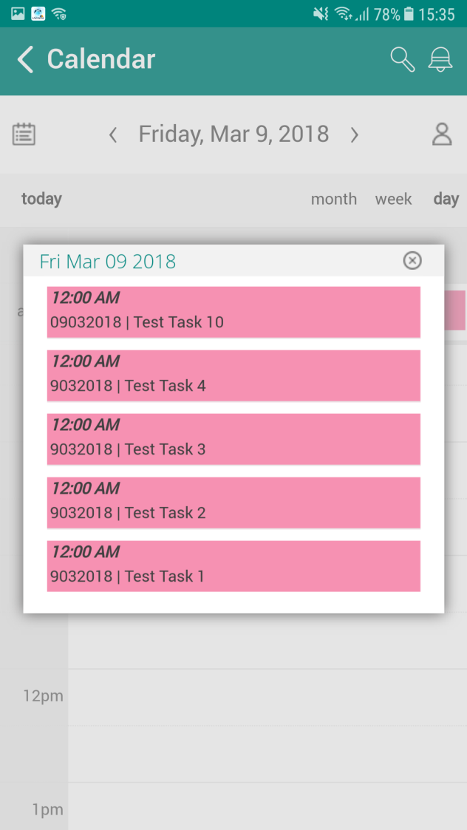

Figure 40: Calendar Task (with time and subject)

# Alerts

Alerts can be accessed from the Alert tile on the homepage, the notification (bell icon) and on the Customer Detail Page (alert section).

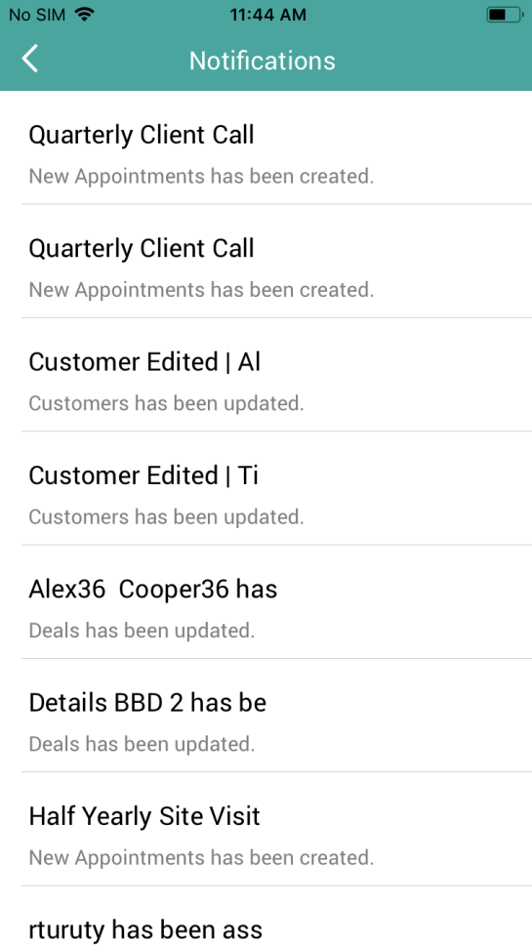

Figure 41: Notifications

On clicking on the Alert tile, the user will be directed to the Alert Views. The following views are available – My Alerts, Actionable Alerts.

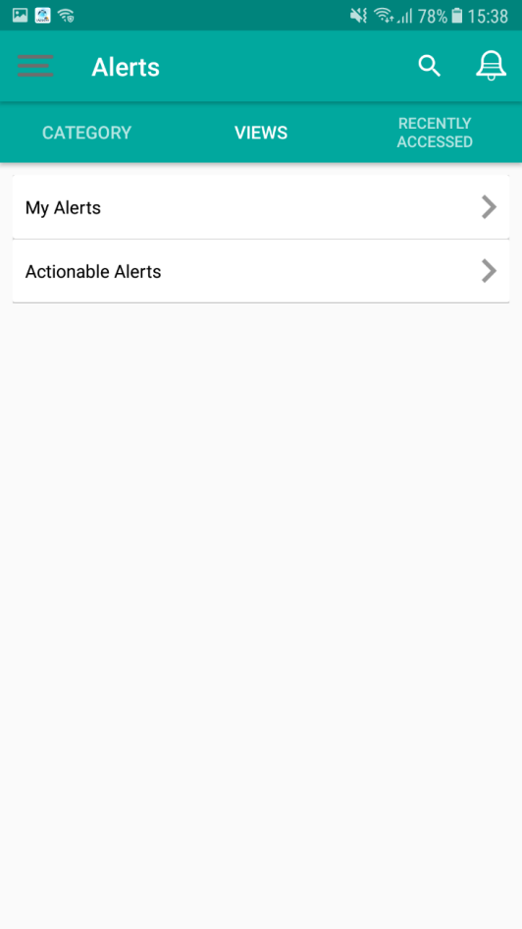

Figure 42: Alert Views

User can only view the alerts in the mobile. For closing the alerts, user will have to use the desktop application.